**Transcription** is the process of making an RNA copy of a gene sequence. This copy, called a messenger RNA (mRNA) molecule, leaves the cell nucleus and enters the cytoplasm, where it directs the synthesis of the protein, which it encodes. Here is a more complete definition of transcription: [**Transcription**](http://www.genome.gov/Glossary/index.cfm?id=197)  
   
**Translation** is the process of translating the sequence of a messenger RNA (mRNA) molecule to a sequence of amino acids during protein synthesis. The genetic code describes the relationship between the sequence of base pairs in a gene and the corresponding amino acid sequence that it encodes. In the cell cytoplasm, the ribosome reads the sequence of the mRNA in groups of three bases to assemble the protein. Here is a more complete definition of translation:[**Translation**](http://www.genome.gov/Glossary/index.cfm?id=200)

**Teachers' Domain: Cell Transcription and Translation**

Teachers' Domain is a free educational resource produced by WGBH with funding from the NSF, which houses thousands of media resources, support materials, and tools for classroom lessons.One of these resources focuses on the topics of transcription and translation.This resource is an interactive activity that starts with a general overview of the central dogma of molecular biology, and then goes into more specific details about the processes of transcription and translation.In addition to the interactive activity, the resource also includes a background narrative and discussion questions that could be used for assessment.Although the material is designated as appropriate content for grades, 9-12, it would serve as an excellent introduction to the topic for biology majors, or would be well suited for non-biology majors at the post-secondary level. **See**: [**Teachers' Domain: Cell Transcription and Translation**](http://www.teachersdomain.org/resource/lsps07.sci.life.stru.celltrans/)

**The DNA Learning Center's (DNALC)   
The Howard Hughes Medical Institute's DNA interactive (DNAi)  
The University of Utah's Genetic Science Learning Center**

The DNA Learning Center's (DNALC) website, the Howard Hughes Medical Institute's DNA interactive (DNAi) website, and the University of Utah's Genetic Science Learning Center website listed below contain excellent narrated animations describing transcription and translation. These animations are useful as a lecture supplement or for students to review on their own. The DNALC animations cover central dogma, transcription (basic and advanced), mRNA splicing, RNA splicing, triplet code and translation (basic and advanced). The DNAi modules," Reading the Code" and "Copying the Code," describe the history of the process, the scientists involved in the discovery, and the basics of the process, and also include an animation and interactive game. Particularly useful to students are the interactive animations from the University of Utah that allow one to, for example,"Transcribe/Translate a Gene"or examine the effects of gene mutation as they "Test Neurofibromin Activity in a Cell."

**The DNA Learning Center's (DNALC):** [**3-D Animation Library**](http://www.dnalc.org/resources/3d/)

**The Howard Hughes Medical Institute's DNA interactive: (DNAi):** [**Code**](http://www.dnai.org/a/index.html)

**The University of Utah's Genetic Science Learning Center:** [**Transcribe and Translate a Gene**](http://learn.genetics.utah.edu/content/molecules/transcribe/)

## Transcription, Translation and Replication

### Contents

1. 1[DNA, RNA and protein synthesis](http://www.atdbio.com/content/14/Transcription-Translation-and-Replication#DNA-RNA-and-protein-synthesis)
2. 2[DNA replication](http://www.atdbio.com/content/14/Transcription-Translation-and-Replication#DNA-replication)
   1. 2.1[Mistakes in DNA replication](http://www.atdbio.com/content/14/Transcription-Translation-and-Replication#Mistakes-in-DNA-replication)
3. 3[Transcription](http://www.atdbio.com/content/14/Transcription-Translation-and-Replication#Transcription)
   1. 3.1[Formation of pre-messenger RNA](http://www.atdbio.com/content/14/Transcription-Translation-and-Replication#Formation-of-pre-messenger-RNA)
   2. 3.2[RNA splicing](http://www.atdbio.com/content/14/Transcription-Translation-and-Replication#RNA-splicing)
   3. 3.3[Alternative splicing](http://www.atdbio.com/content/14/Transcription-Translation-and-Replication#Alternative-splicing)
   4. 3.4[Reverse transcription](http://www.atdbio.com/content/14/Transcription-Translation-and-Replication#Reverse-transcription)
4. 4[Translation](http://www.atdbio.com/content/14/Transcription-Translation-and-Replication#Translation)
5. 5[Transfer RNA](http://www.atdbio.com/content/14/Transcription-Translation-and-Replication#Transfer-RNA)
6. 6[The Genetic code](http://www.atdbio.com/content/14/Transcription-Translation-and-Replication#The-Genetic-code)
   1. 6.1[An exercise in the use of the genetic code](http://www.atdbio.com/content/14/Transcription-Translation-and-Replication#An-exercise-in-the-use-of-the-genetic-code)
7. 7[The Wobble hypothesis](http://www.atdbio.com/content/14/Transcription-Translation-and-Replication#The-Wobble-hypothesis)

### DNA, RNA and protein synthesis

The genetic material is stored in the form of DNA in most organisms. In humans, the nucleus of each cell contains 3 × 109 base pairs of DNA distributed over 23 pairs of chromosomes, and each cell has two copies of the genetic material. This is known collectively as the human genome. The human genome contains around 30 000 genes, each of which codes for one protein.

Large stretches of DNA in the human genome are transcribed but do not code for proteins. These regions are called introns and make up around 95% of the genome. The nucleotide sequence of the human genome is now known to a reasonable degree of accuracy but we do not yet understand why so much of it is non-coding. Some of this non-coding DNA controls gene expression but the purpose of much of it is not yet understood. This is a fascinating subject that is certain to advance rapidly over the next few years.

The Central Dogma of Molecular Biology states that **DNA makes RNA makes proteins** ([Figure 1](http://www.atdbio.com/content/14/Transcription-Translation-and-Replication#figure-central-dogma)).

[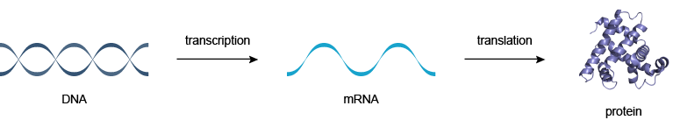](http://www.atdbio.com/img/articles/central-dogma-large.png)

Figure 1 | The Central Dogma of Molecular Biology: DNA makes RNA makes proteins

The process by which DNA is copied to RNA is called [transcription](http://www.atdbio.com/content/14/Transcription-Translation-and-Replication#Transcription), and that by which RNA is used to produce proteins is called [translation](http://www.atdbio.com/content/14/Transcription-Translation-and-Replication#Translation).

### DNA replication

Each time a cell divides, each of its double strands of DNA splits into two single strands. Each of these single strands acts as a template for a new strand of complementary DNA. As a result, each new cell has its own complete genome. This process is known as DNA replication. Replication is controlled by the Watson-Crick pairing of the bases in the template strand with incoming deoxynucleotide triphosphates, and is directed by DNA polymerase enzymes. It is a complex process, particularly in eukaryotes, involving an array of enzymes. A simplified version of bacterial DNA replication is described in [Figure 2](http://www.atdbio.com/content/14/Transcription-Translation-and-Replication#figure-DNA-replication).

[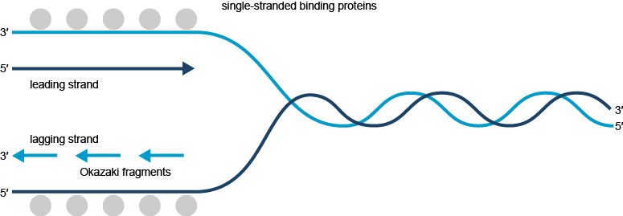](http://www.atdbio.com/img/articles/DNA-replication-large.png)

Figure 2 | DNA replication in bacteriaSimplified representation of DNA replication in bacteria.

DNA biosynthesis proceeds in the 5′- to 3′-direction. This makes it impossible for DNA polymerases to synthesize both strands simultaneously. A portion of the double helix must first unwind, and this is mediated by helicase enzymes.

The leading strand is synthesized continuously but the opposite strand is copied in short bursts of about 1000 bases, as the lagging strand template becomes available. The resulting short strands are called Okazaki fragments (after their discoverers, Reiji and Tsuneko Okazaki). Bacteria have at least three distinct DNA polymerases: Pol I, Pol II and Pol III; it is Pol III that is largely involved in chain elongation. Strangely, DNA polymerases cannot initiate DNA synthesis de novo, but require a short primer with a free 3′-hydroxyl group. This is produced in the lagging strand by an RNA polymerase (called DNA primase) that is able to use the DNA template and synthesize a short piece of RNA around 20 bases in length. Pol III can then take over, but it eventually encounters one of the previously synthesized short RNA fragments in its path. At this point Pol I takes over, using its 5′- to 3′-exonuclease activity to digest the RNA and fill the gap with DNA until it reaches a continuous stretch of DNA. This leaves a gap between the 3′-end of the newly synthesized DNA and the 5′-end of the DNA previously synthesized by Pol III. The gap is filled by DNA ligase, an enzyme that makes a covalent bond between a 5′-phosphate and a 3′-hydroxyl group ([Figure 3](http://www.atdbio.com/content/14/Transcription-Translation-and-Replication#figure-DNA-replication-polymerases)). The initiation of DNA replication at the leading strand is more complex and is discussed in detail in more specialized texts.

[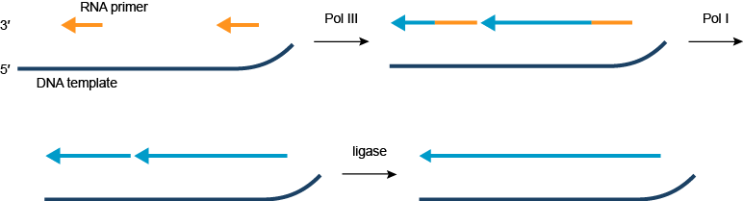](http://www.atdbio.com/img/articles/DNA-replication-polymerases-large.png)

Figure 3 | DNA polymerases in DNA replicationSimplified representation of the action of DNA polymerases in DNA replication in bacteria.

#### Mistakes in DNA replication

DNA replication is not perfect. Errors occur in DNA replication, when the incorrect base is incorporated into the growing DNA strand. This leads to mismatched base pairs, or mispairs. DNA polymerases have proofreading activity, and a [DNA repair](http://www.atdbio.com/content/15/Mutagenesis-and-DNA-repair#DNA-repair-mechanisms) enzymes have evolved to correct these mistakes. Occasionally, mispairs survive and are incorporated into the genome in the next round of replication. These mutations may have no consequence, they may result in the death of the organism, they may result in a genetic disease or cancer; or they may give the organism a competitive advantage over its neighbours, which leads to evolution by natural selection.

### Transcription

Transcription is the process by which DNA is copied (transcribed) to mRNA, which carries the information needed for protein synthesis. Transcription takes place in two broad steps. First, pre-messenger RNA is formed, with the involvement of RNA polymerase enzymes. The process relies on Watson-Crick base pairing, and the resultant single strand of RNA is the reverse-complement of the original DNA sequence. The pre-messenger RNA is then "edited" to produce the desired mRNA molecule in a process called RNA splicing.

#### Formation of pre-messenger RNA

The mechanism of transcription has parallels in that of [DNA replication](http://www.atdbio.com/content/14/Transcription-Translation-and-Replication#DNA-replication). As with DNA replication, partial unwinding of the double helix must occur before transcription can take place, and it is the RNA polymerase enzymes that catalyze this process.

Unlike DNA replication, in which both strands are copied, only one strand is transcribed. The strand that contains the gene is called the sense strand, while the complementary strand is the antisense strand. The mRNA produced in transcription is a copy of the sense strand, but it is the antisense strand that is transcribed.

Ribonucleotide triphosphates (NTPs) align along the antisense DNA strand, with Watson-Crick base pairing (A pairs with U). RNA polymerase joins the ribonucleotides together to form a pre-messenger RNA molecule that is complementary to a region of the antisense DNA strand. Transcription ends when the RNA polymerase enzyme reaches a triplet of bases that is read as a "stop" signal. The DNA molecule re-winds to re-form the double helix.

[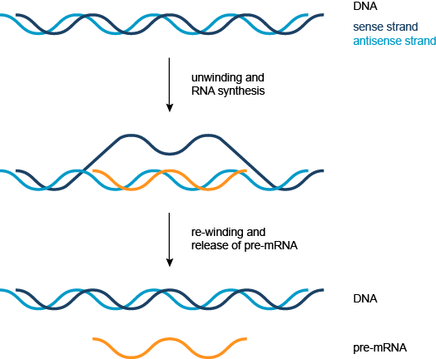](http://www.atdbio.com/img/articles/transcription-large.png)

Figure 4 | TranscriptionSimplified representation of the formation of pre-messenger RNA (orange) from double-stranded DNA (blue) in transcription.

#### RNA splicing

The pre-messenger RNA thus formed contains introns which are not required for protein synthesis. The pre-messenger RNA is chopped up to remove the introns and create messenger RNA (mRNA) in a process called RNA splicing ([Figure 5](http://www.atdbio.com/content/14/Transcription-Translation-and-Replication#figure-RNA-splicing)).

[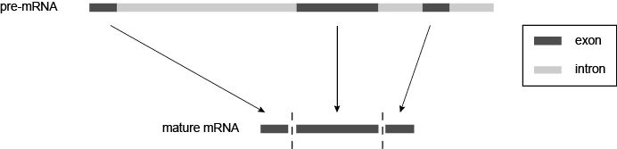](http://www.atdbio.com/img/articles/RNA-splicing-large.png)

Figure 5 | RNA splicingIntrons are spliced from the pre-messenger RNA to give messenger RNA (mRNA).

#### Alternative splicing

In alternative splicing, individual exons are either spliced or included, giving rise to several different possible mRNA products. Each mRNA product codes for a different protein isoform; these protein isoforms differ in their peptide sequence and therefore their biological activity. It is estimated that up to 60% of human gene products undergo alternative splicing. Several different mechanisms of alternative splicing are known, two of which are illustrated in [Figure 6](http://www.atdbio.com/content/14/Transcription-Translation-and-Replication#figure-alternative-splicing).

[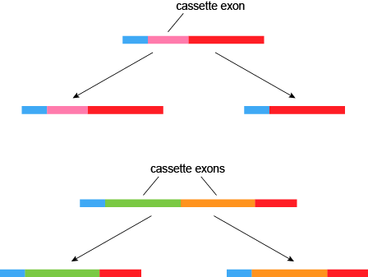](http://www.atdbio.com/img/articles/alternative-splicing-large.png)

Figure 6 | Alternative splicingSeveral different mechanisms of alternative splicing exist − a cassette exon can be either included in or excluded from the final RNA (top), or two cassette exons may be mutually exclusive (bottom).

Alternative splicing contributes to protein diversity − a single gene transcript (RNA) can have thousands of different splicing patterns, and will therefore code for thousands of different proteins: a diverse proteome is generated from a relatively limited genome. Splicing is important in genetic regulation (alteration of the splicing pattern in response to cellular conditions changes protein expression). Perhaps not surprisingly, abnormal splicing patterns can lead to disease states including cancer.

#### Reverse transcription

In reverse transcription, RNA is "reverse transcribed" into DNA. This process, catalyzed by reverse transcriptase enzymes, allows retroviruses, including the human immunodeficiency virus (HIV), to use RNA as their genetic material. Reverse transcriptase enzymes have also found applications in biotechnology, allowing scientists to convert RNA to DNA for techniques such as [PCR](http://www.atdbio.com/content/20/Sequencing-forensic-analysis-and-genetic-analysis#The-Polymerase-Chain-Reaction-PCR).

### Translation

The mRNA formed in transcription is transported out of the nucleus, into the cytoplasm, to the ribosome (the cell's protein synthesis factory). Here, it directs protein synthesis. Messenger RNA is not directly involved in protein synthesis − transfer RNA (tRNA) is required for this. The process by which mRNA directs protein synthesis with the assistance of tRNA is called translation.

The ribosome is a very large complex of RNA and protein molecules. Each three-base stretch of mRNA (triplet) is known as a codon, and one codon contains the information for a specific amino acid. As the mRNA passes through the ribosome, each codon interacts with the anticodon of a specific transfer RNA (tRNA) molecule by Watson-Crick base pairing. This tRNA molecule carries an amino acid at its 3′-terminus, which is incorporated into the growing protein chain. The tRNA is then expelled from the ribosome. [Figure 7](http://www.atdbio.com/content/14/Transcription-Translation-and-Replication#figure-translation) shows the steps involved in protein synthesis.

[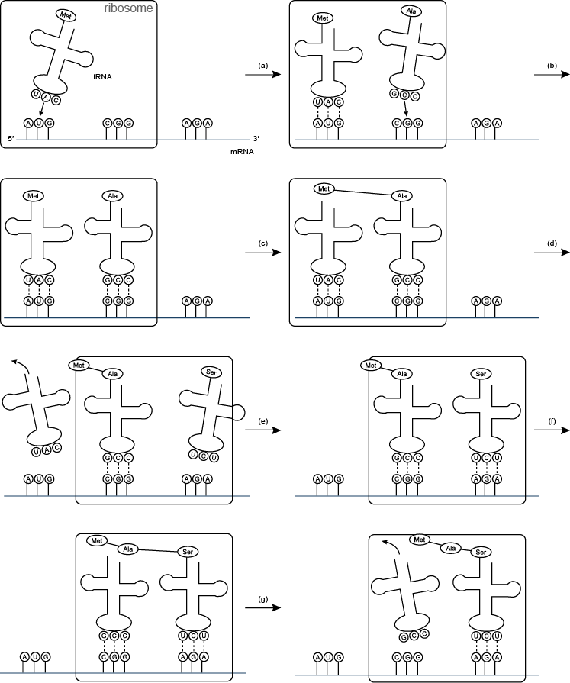](http://www.atdbio.com/img/articles/translation-large.png)

Figure 7 | Translation(a) and (b) tRNA molecules bind to the two binding sites of the ribosome, and by hydrogen bonding to the mRNA; (c) a peptide bond forms between the two amino acids to make a dipeptide, while the tRNA molecule is left uncharged; (d) the uncharged tRNA molecule leaves the ribosome, while the ribosome moves one codon to the right (the dipeptide is translocated from one binding site to the other); (e) another tRNA molecule binds; (f) a peptide bond forms between the two amino acids to make a tripeptide; (g) the uncharged tRNA molecule leaves the ribosome.

### Transfer RNA

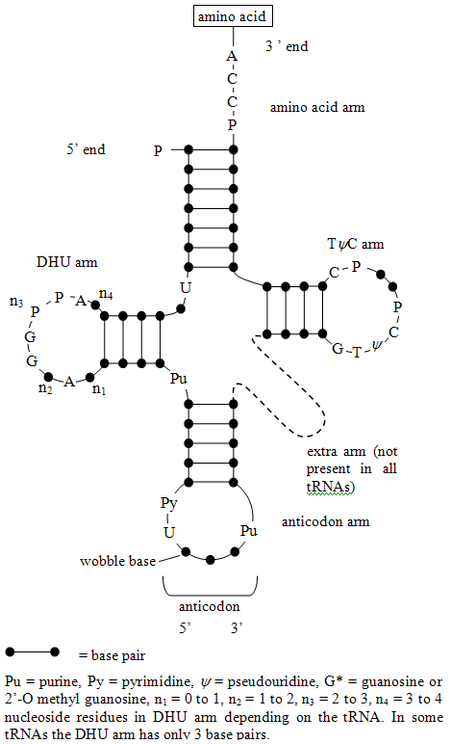

Figure 8 | Two-dimensional structures of tRNA (transfer RNA)In some tRNAs the DHU arm has only three base pairs.

Each amino acid has its own special tRNA (or set of tRNAs). For example, the tRNA for phenylalanine (tRNAPhe) is different from that for histidine (tRNAHis). Each amino acid is attached to its tRNA through the 3′-OH group to form an ester which reacts with the α-amino group of the terminal amino-acid of the growing protein chain to form a new amide bond (peptide bond) during protein synthesis ([Figure 9](http://www.atdbio.com/content/14/Transcription-Translation-and-Replication#figure-protein-synthesis-tRNA)). The reaction of esters with amines is generally favourable but the rate of reaction is increased greatly in the ribosome.

[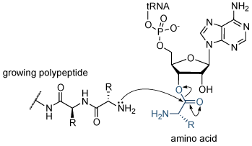](http://www.atdbio.com/img/articles/protein-synthesis-tRNA-large.png)

Figure 9 | Protein synthesisReaction of the growing polypeptide chain with the 3′-end of the charged tRNA. The amino acid is transferred from the tRNA molecule to the protein.

Each transfer RNA molecule has a well defined tertiary structure that is recognized by the enzyme aminoacyl tRNA synthetase, which adds the correct amino acid to the 3′-end of the uncharged tRNA. The presence of modified nucleosides is important in stabilizing the tRNA structure. Some of these modifications are shown in [Figure 10](http://www.atdbio.com/content/14/Transcription-Translation-and-Replication#figure-tRNA-modified-bases).

[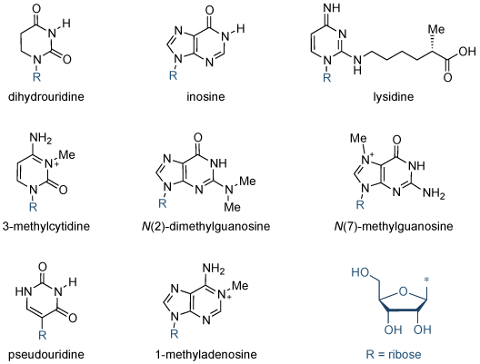](http://www.atdbio.com/img/articles/tRNA-modified-bases-large.png)

Figure 10 | Modified bases in tRNAStructures of some of the modified bases found in tRNA.

### The Genetic code

The genetic code is almost universal. It is the basis of the transmission of hereditary information by nucleic acids in all organisms. There are four bases in RNA (A,G,C and U), so there are 64 possible triplet codes (43 = 64). In theory only 22 codes are required: one for each of the 20 naturally occurring amino acids, with the addition of a start codon and a stop codon (to indicate the beginning and end of a protein sequence). Many amino acids have several codes (degeneracy), so that all 64 possible triplet codes are used. For example Arg and Ser each have 6 codons whereas Trp and Met have only one. No two amino acids have the same code but amino acids whose side-chains have similar physical or chemical properties tend to have similar codon sequences, e.g. the side-chains of Phe, Leu, Ile, Val are all hydrophobic, and Asp and Glu are both carboxylic acids (see [Figure 11](http://www.atdbio.com/content/14/Transcription-Translation-and-Replication#figure-genetic-code)). This means that if the incorrect tRNA is selected during translation (owing to mispairing of a single base at the codon-anticodon interface) the misincorporated amino acid will probably have similar properties to the intended tRNA molecule. Although the resultant protein will have one incorrect amino acid it stands a high probability of being functional. Organisms show "codon bias" and use certain codons for a particular amino acid more than others. For example, the codon usage in humans is different from that in bacteria; it can sometimes be difficult to express a human protein in bacteria because the relevant tRNA might be present at too low a concentration.

[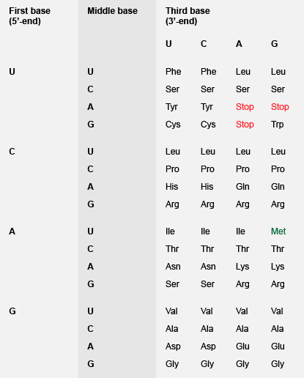](http://www.atdbio.com/img/articles/genetic-code-large.png)

Figure 11 | The Genetic code − triplet codon assignments for the 20 amino acids. As well as coding for methionine, AUG is used as a start codon, initiating protein biosynthesis

#### An exercise in the use of the genetic code

One strand of genomic DNA (strand A, coding strand) contains the following sequence reading from 5′- to 3′-:

TCGTCGACGATGATCATCGGCTACTCGA

This strand will form the following duplex:

5′-TCGTCGACGATGATCATCGGCTACTCGA-3'  
3′-AGCAGCTGCTACTAGTAGCCGATGAGCT-5'

The sequence of bases in the other strand of DNA (strand B) written 5′- to 3′- is therefore

TCGAGTAGCCGATGATCATCGTCGACGA

The sequence of bases in the mRNA transcribed from strand A of DNA written 5′- to 3′- is

UCGAGUAGCCGAUGAUCAUCGUCGACGA

The amino acid sequence coded by the above mRNA is

Ser-Ser-Ser-Arg-STOP

However, if DNA strand B is the coding strand the mRNA sequence will be:

UCGUCGACGAUGAUCAUCGGCUACUCGA

and the amino-acid sequence will be:

Ser-Ser-Thr-Arg-Ser-Ser-Gly-Cys-Ser-

### The Wobble hypothesis

Close inspection of all of the available codons for a particular amino acid reveals that the variation is greatest in the third position (for example, the codons for alanine are GCU, GCC, GCA and GCG). Crick and Brenner proposed that a single tRNA molecule can recognize codons with different bases at the 3′-end owing to non-Watson-Crick base pair formation with the third base in the codon-anticodon interaction. These non-standard base pairs are different in shape from A·U and G·C and the term wobble hypothesis indicates that a certain degree of flexibility or "wobbling" is allowed at this position in the ribosome. Not all combinations are possible; examples of "allowed" pairings are shown in [Figure 12](http://www.atdbio.com/content/14/Transcription-Translation-and-Replication#figure-RNA-wobble-base-pairs).

[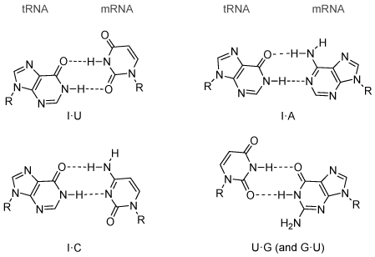](http://www.atdbio.com/img/articles/RNA-wobble-base-pairs-large.png)

Figure 12 | Structures of wobble base pairs found in RNA

The ability of DNA bases to form wobble base pairs as well as Watson-Crick base pairs can result in [base-pair mismatches](http://www.atdbio.com/content/15/Mutagenesis-and-DNA-repair#Mismatches-in-DNA-bases) occurring during DNA replication. If not repaired by [DNA repair enzymes](http://www.atdbio.com/content/15/Mutagenesis-and-DNA-repair#DNA-repair-mechanisms), these mismatches can lead to genetic diseases and cancer.

# Ribosomes, Transcription, and Translation

The genetic information stored in DNA is a living archive of instructions that cells use to accomplish the functions of life. Inside each cell, catalysts seek out the appropriate information from this archive and use it to build new proteins — proteins that make up the structures of the cell, run the biochemical reactions in the cell, and are sometimes manufactured for export. Although all of the cells that make up a multicellular organism contain identical genetic information, functionally different cells within the organism use different sets of catalysts to express only specific portions of these instructions to accomplish the functions of life.

## How Is Genetic Information Passed on in Dividing Cells?

When a cell divides, it creates one copy of its genetic information — in the form of DNA molecules — for each of the two resulting daughter cells. The accuracy of these copies determines the health and inherited features of the nascent cells, so it is essential that the process of DNA **replication** be as accurate as possible (Figure 1).

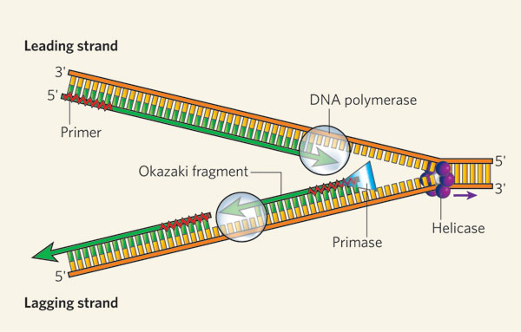

Figure 1: DNA replication of the leading and lagging strand

The helicase unzips the double-stranded DNA for replication, making a forked structure. The primase generates short strands of RNA that bind to the single-stranded DNA to initiate DNA synthesis by the DNA polymerase. This enzyme can work only in the 5' to 3' direction, so it replicates the leading strand continuously. Lagging-strand replication is discontinuous, with short Okazaki fragments being formed and later linked together.

© 2006 [Nature Publishing Group](http://www.nature.com) Bell, S. D. Molecular biology: Prime-time progress. *Nature* **439,** 542-543 (2006). All rights reserved. [Description: View Terms of Use](javascript:show_inform(%22Terms%20of%20Use%22,%20%22Nature%20Education%20has%20been%20granted%20permission%20to%20this%20material%20in%20Scitable%20but%20is%20not%20authorized%20to%20sublicense%20you%20to%20use%20this%20material%20outside%20of%20Scitable%20except%20for%20the%20following%20two%20circumstances.%20%20You%20may%20reproduce%20this%20material,%20without%20modifications,%20in%20print%20form%20for%20your%20personal,%20non-commercial%20use%20or%20in%20print%20form%20for%20non-commercial%20use%20in%20an%20educational%20environment.%20%20To%20obtain%20permission%20for%20usage%20beyond%20these%20cases,%20please%20contact%20the%20original%20publisher.%22);)

[Figure Detail](javascript:void(0))

One factor that helps ensure precise [replication](http://www.nature.com/scitable/topicpage/cells-can-replicate-their-dna-precisely-6524830) is the [double-helical structure of DNA](http://www.nature.com/scitable/topicpage/dna-is-a-structure-that-encodes-biological-6493050) itself. In particular, the two strands of the DNA double helix are made up of combinations of molecules called **nucleotides**. DNA is constructed from just four different nucleotides — **adenine** (A), **thymine** (T), **cytosine** (C), and **guanine** (G) — each of which is named for the nitrogenous base it contains. Moreover, the nucleotides that form one strand of the DNA double helix always bond with the nucleotides in the other strand according to a pattern known as **complementary base-pairing** — specifically, A always pairs with T, and C always pairs with G (Figure 2). Thus, during cell division, the paired strands unravel and each strand serves as the template for synthesis of a new complementary strand.

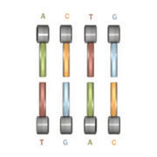

Each nucleotide has an affinity for its partner: A pairs with T, and C pairs with G.

© 2009 [Nature Education](http://www.nature.com/nature_education) All rights reserved. [Description: View Terms of Use](javascript:show_inform(%22Terms%20of%20Use%22,%20%22You%20may%20reproduce%20this%20material,%20without%20modifications,%20in%20print%20or%20electronic%20form%20for%20your%20personal,%20non-commercial%20purposes%20or%20for%20non-commercial%20use%20in%20an%20educational%20environment.%22);)

In most multicellular organisms, every cell carries the same DNA, but this genetic information is used in varying ways by different types of cells. In other words, what a cell "does" within an organism dictates which of its genes are expressed. Nerve cells, for example, synthesize an abundance of chemicals called neurotransmitters, which they use to send messages to other cells, whereas muscle cells load themselves with the protein-based filaments necessary for muscle contractions.

## What Are the Initial Steps in Accessing Genetic Information?

**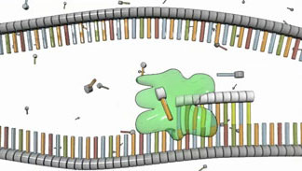**

**Figure 3: RNA polymerase at work**

**RNA polymerase (green) synthesizes a strand of RNA that is complementary to the DNA template strand below it.**

**© 2009** [Nature Education](http://www.nature.com/nature_education) **All rights reserved. [Description: View Terms of Use](javascript:show_inform(%22Terms%20of%20Use%22,%20%22You%20may%20reproduce%20this%20material,%20without%20modifications,%20in%20print%20or%20electronic%20form%20for%20your%20personal,%20non-commercial%20purposes%20or%20for%20non-commercial%20use%20in%20an%20educational%20environment.%22);)**

**Transcription** is the first step in decoding a cell's genetic information. During [transcription](http://www.nature.com/scitable/topicpage/the-information-in-dna-is-decoded-by-6524808), enzymes called **RNA polymerases** build RNA molecules that are complementary to a portion of one strand of the DNA double helix (Figure 3).

RNA molecules differ from DNA molecules in several important ways: They are single stranded rather than double stranded; their sugar component is a ribose rather than a deoxyribose; and they include **uracil** (U) nucleotides rather than thymine (T) nucleotides (Figure 4). Also, because they are single strands, RNA molecules don't form helices; rather, they fold into complex structures that are stabilized by internal complementary base-pairing.

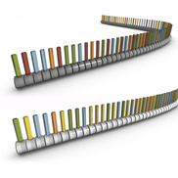

Figure 4: DNA (top) includes thymine (red); in RNA (bottom), thymine is replaced by uracil (yellow)

© 2009 [Nature Education](http://www.nature.com/nature_education) All rights reserved. [Description: View Terms of Use](javascript:show_inform(%22Terms%20of%20Use%22,%20%22You%20may%20reproduce%20this%20material,%20without%20modifications,%20in%20print%20or%20electronic%20form%20for%20your%20personal,%20non-commercial%20purposes%20or%20for%20non-commercial%20use%20in%20an%20educational%20environment.%22);)

Three general classes of RNA molecules are involved in expressing the genes encoded within a cell's DNA. **Messenger RNA** (mRNA) molecules carry the coding sequences for protein synthesis and are called transcripts; **ribosomal RNA** (rRNA) molecules form the core of a cell's ribosomes (the structures in which protein synthesis takes place); and **transfer RNA** (tRNA) molecules carry amino acids to the ribosomes during protein synthesis. In eukaryotic cells, each class of RNA has its own polymerase, whereas in prokaryotic cells, a single RNA polymerase synthesizes the different class of RNA. Other types of RNA also exist but are not as well understood, although they appear to play regulatory roles in gene expression and also be involved in protection against invading viruses.

mRNA is the most variable class of RNA, and there are literally thousands of different mRNA molecules present in a cell at any given time. Some mRNA molecules are abundant, numbering in the hundreds or thousands, as is often true of transcripts encoding structural proteins. Other mRNAs are quite rare, with perhaps only a single copy present, as is sometimes the case for transcripts that encode signaling proteins. mRNAs also vary in how long-lived they are. In eukaryotes, transcripts for structural proteins may remain intact for over ten hours, whereas transcripts for signaling proteins may be degraded in less than ten minutes.

Cells can be characterized by the spectrum of mRNA molecules present within them; this spectrum is called the **transcriptome**. Whereas each cell in a multicellular organism carries the same DNA or genome, its transcriptome varies widely according to cell type and function. For instance, the insulin-producing cells of the pancreas contain transcripts for insulin, but bone cells do not. Even though bone cells carry the gene for insulin, this gene is not transcribed. Therefore, the transcriptome functions as a kind of catalog of all of the genes that are being expressed in a cell at a particular point in time.

## What Is the Function of Ribosomes?

**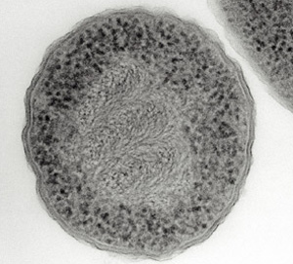**

**Figure 5: An electron micrograph of a prokaryote (*Escherichia coli*), showing DNA and ribosomes**

**This *Escherichia coli* cell has been treated with chemicals and sectioned so its DNA and ribosomes are clearly visible. The DNA appears as swirls in the center of the cell, and the ribosomes appear as dark particles at the cell periphery.**

**Courtesy of Dr. Abraham Minsky (2014). All rights reserved. [Description: View Terms of Use](javascript:show_inform(%22Terms%20of%20Use%22,%20%22Nature%20Education%20has%20been%20granted%20permission%20to%20this%20material%20in%20Scitable%20but%20is%20not%20authorized%20to%20sublicense%20you%20to%20use%20this%20material%20outside%20of%20Scitable%20except%20for%20the%20following%20two%20circumstances.%20%20You%20may%20reproduce%20this%20material,%20without%20modifications,%20in%20print%20form%20for%20your%20personal,%20non-commercial%20use%20or%20in%20print%20form%20for%20non-commercial%20use%20in%20an%20educational%20environment.%20%20To%20obtain%20permission%20for%20usage%20beyond%20these%20cases,%20please%20contact%20the%20original%20publisher.%22);)**

**Ribosomes** are the sites in a cell in which protein synthesis takes place. Cells have many ribosomes, and the exact number depends on how active a particular cell is in synthesizing proteins. For example, rapidly growing cells usually have a large number of ribosomes (Figure 5).

Ribosomes are complexes of rRNA molecules and proteins, and they can be observed in electron micrographs of cells. Sometimes, ribosomes are visible as clusters, called polyribosomes. In eukaryotes (but not in prokaryotes), some of the ribosomes are attached to internal membranes, where they synthesize the proteins that will later reside in those membranes, or are destined for secretion (Figure 6). Although only a few rRNA molecules are present in each ribosome, these molecules make up about half of the ribosomal mass. The remaining mass consists of a number of proteins — nearly 60 in prokaryotic cells and over 80 in eukaryotic cells.

Within the ribosome, the rRNA molecules direct the catalytic steps of protein synthesis — the stitching together of amino acids to make a protein molecule. In fact, rRNA is sometimes called a ribozyme or catalytic RNA to reflect this function.

Eukaryotic and prokaryotic ribosomes are different from each other as a result of divergent evolution. These differences are exploited by antibiotics, which are designed to inhibit the prokaryotic ribosomes of infectious bacteria without affecting eukaryotic ribosomes, thereby not interfering with the cells of the sick host.

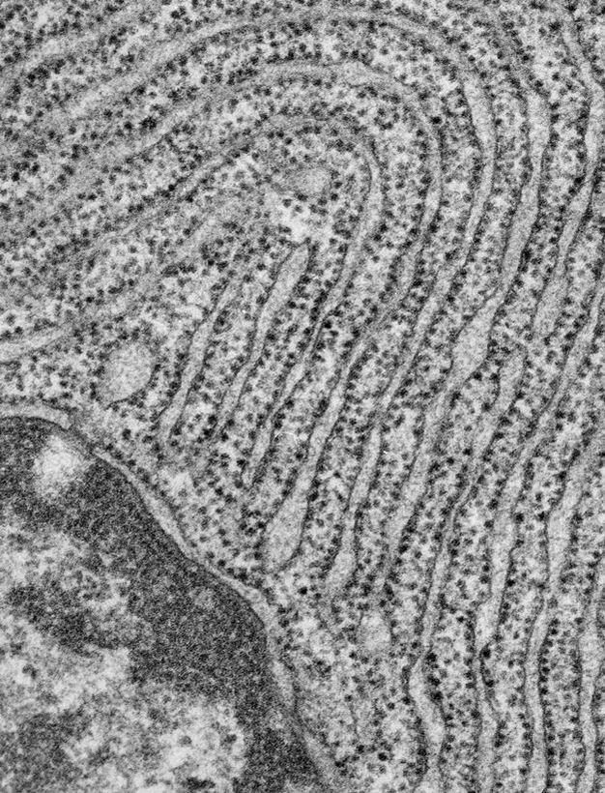

Figure 6: The endoplasmic reticulum of this eukaryotic cell is studded with ribosomes.

Electron micrograph of a pancreatic exocrine cell section. The cytosol is filled with closely packed sheets of endoplasmic reticulum membrane studded with ribosomes. At the bottom left is a portion of the nucleus and its nuclear envelope. Image courtesy of Prof. L. Orci (University of Geneva, Switzerland).

© 2014 [Nature Publishing Group](http://www.nature.com) Schekman, R. Merging cultures in the study of membrane traffic. *Nature Cell Biology* **6**, 483-486 (2004) doi:10.1038/ncb0604-483. All rights reserved. [Description: View Terms of Use](javascript:show_inform(%22Terms%20of%20Use%22,%20%22Nature%20Education%20has%20been%20granted%20permission%20to%20this%20material%20on%20this%20site,%20but%20is%20not%20authorized%20to%20sublicense%20you%20to%20use%20this%20material%20outside%20of%20this%20site,%20except%20for%20the%20following%20two%20circumstances.%20You%20may%20reproduce%20this%20material,%20without%20modifications,%20in%20print%20form%20for%20your%20personal,%20non-commercial%20use%20or%20in%20print%20form%20for%20non-commercial%20use%20in%20an%20educational%20environment.%20To%20obtain%20permission%20for%20usage%20beyond%20these%20cases,%20please%20contact%20the%20original%20publisher.%22);)

## How Does the Whole Process Result in New Proteins?

After the transcription of DNA to mRNA is complete, **translation** — or the reading of these mRNAs to make proteins — begins. Recall that mRNA molecules are single stranded, and the order of their bases — A, U, C, and G — is complementary to that in specific portions of the cell's DNA. Each mRNA dictates the order in which amino acids should be added to a growing protein as it is synthesized. In fact, every amino acid is represented by a three-nucleotide sequence or **codon** along the mRNA molecule. For example, AGC is the mRNA codon for the amino acid serine, and UAA is a signal to stop translating a protein — also called the **stop codon** (Figure 7).

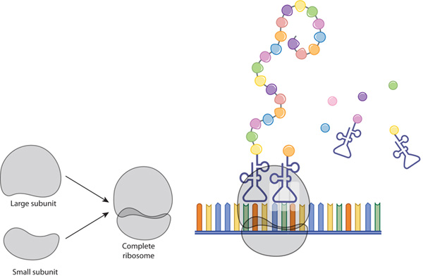

Figure 7: The ribosome and translation

A ribosome is composed of two subunits: large and small. During translation, ribosomal subunits assemble together like a sandwich on the strand of mRNA, where they proceed to attract tRNA molecules tethered to amino acids (circles). A long chain of amino acids emerges as the ribosome decodes the mRNA sequence into a polypeptide, or a new protein.

© 2010 [Nature Education](http://www.nature.com/nature_education) All rights reserved. [Description: View Terms of Use](javascript:show_inform(%22Terms%20of%20Use%22,%20%22You%20may%20reproduce%20this%20material,%20without%20modifications,%20in%20print%20or%20electronic%20form%20for%20your%20personal,%20non-commercial%20purposes%20or%20for%20non-commercial%20use%20in%20an%20educational%20environment.%22);)

[Figure Detail](javascript:void(0))

Molecules of tRNA are responsible for matching amino acids with the appropriate codons in mRNA. Each tRNA molecule has two distinct ends, one of which binds to a specific amino acid, and the other which binds to the corresponding mRNA codon. During [translation](http://www.nature.com/scitable/topicpage/the-information-in-dna-determines-cellular-function-6523228), these tRNAs carry amino acids to the ribosome and join with their complementary codons. Then, the assembled amino acids are joined together as the ribosome, with its resident rRNAs, moves along the mRNA molecule in a ratchet-like motion. The resulting protein chains can be hundreds of amino acids in length, and synthesizing these molecules requires a huge amount of chemical energy (Figure 8).

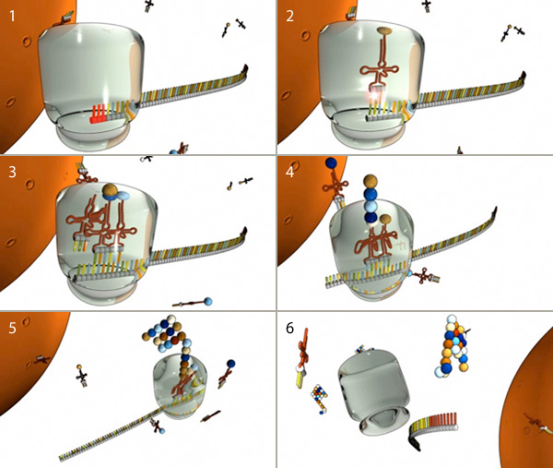

Figure 8: The major steps of translation

(1) Translation begins when a ribosome (gray) docks on a start codon (red) of an mRNA molecule in the cytoplasm. (2) Next, tRNA molecules attached to amino acids (spheres) dock at the corresponding triplet codon sequence on the mRNA molecule. (3, 4, and 5) This process repeats over and over, with multiple tRNAs docking and connecting successive amino acids into a growing chain that elongates out of the top of the ribosome. (6) When the ribosome encounters a stop codon, it falls off the mRNA molecule and releases the protein for use in the cell.

© 2010 [Nature Education](http://www.nature.com/nature_education) All rights reserved. [Description: View Terms of Use](javascript:show_inform(%22Terms%20of%20Use%22,%20%22You%20may%20reproduce%20this%20material,%20without%20modifications,%20in%20print%20or%20electronic%20form%20for%20your%20personal,%20non-commercial%20purposes%20or%20for%20non-commercial%20use%20in%20an%20educational%20environment.%22);)

[Figure Detail](javascript:void(0))

In prokaryotic cells, transcription (DNA to mRNA) and translation (mRNA to protein) are so closely linked that translation usually begins before transcription is complete. In eukaryotic cells, however, the two processes are separated in both space and time: mRNAs are synthesized in the nucleus, and proteins are later made in the cytoplasm.

## Conclusion

## Cellular DNA contains instructions for building the various proteins the cell needs to survive. In order for a cell to manufacture these proteins, specific genes within its DNA must first be transcribed into molecules of mRNA; then, these transcripts must be translated into chains of amino acids, which later fold into fully functional proteins. Although all of the cells in a multicellular organism contain the same set of genetic information, the transcriptomes of different cells vary depending on the cells' structure and function in the organism. Comparison chart

| Transcription versus Translation comparison chart | | |
| --- | --- | --- |
| [Description: Edit this comparison chart](http://www.diffen.com/difference/Special:EditTable?diffenVal1=Transcription&diffenVal2=Translation) | **Transcription** | **Translation** |
| **Purpose** | The purpose of [transcription](http://www.diffen.com/difference/Transcription_vs_Translation) is to make RNA copies of individual genes that the cell can use in the biochemistry. | The purpose of translation is to synthesize proteins, which are used for millions of cellular functions. |
| **Definition** | Uses the [genes](http://www.diffen.com/difference/Allele_vs_Gene) as templates to produce several functional forms of RNA | Translation is the synthesis of a protein from an mRNA template. This is the second step of gene expression. Uses rRNA as assembly plant; and tRNA as the translator to produce a protein. |
| **Products** | mRNA, tRNA, rRNA and non-coding RNA( like microRNA) | Proteins |
| **Product processing** | A 5’ cap is added, a 3’ poly A tail is added and introns are spliced out. | A number of post-translational modifications occur including phosphorylation, SUMOylation, disulfide bridges and farnesylation. |
| **Location** | Nucleus | Cytoplasm |
| **Initiation** | Occurs when RNA polymerase protein binds to the promoter in DNA and forms a transcription initiation complex. Promoter directs the exact location for the initiation of transcription. | Occurs when ribosome subunits, initiation factors and t-RNA bind the mRNA near the AUG start codon. |
| **Termination** | RNA transcript is released and polymerase detaches from DNA. DNA rewinds itself into a double-helix and is unaltered throughout this process. | When the ribosome encounters one of the three stop codons it disassembles the ribosome and releases the polypeptide. |
| **Elongation** | RNA polymerase elongates in the 5' --> 3' direction | The incoming aminoacyl t-RNA binds to the codon at A-site and a peptide bond is formed between new amino acid and growing chain. Peptide then moves one codon position to get ready for the next amino acid. It then proceeds in a 5' to 3’ direction. |
| **Antibiotics** | Transcription is inhibited by rifampicin and 8-Hydroxyquinoline. | Translation is inhibited by anisomycin, cycloheximide, chloramphenicol, tetracyclin, streptomycin, erythromycin and puromycin. |
| **Localization** | Found in [prokaryotes](http://www.diffen.com/difference/Eukaryotic_Cell_vs_Prokaryotic_Cell)' cytoplasm and in a eukaryote's nucleus | Found in prokaryotes' cytoplasm and in [eukaryotes](http://www.diffen.com/difference/Eukaryotic_Cell_vs_Prokaryotic_Cell)' ribosomes on endoplasmic reticulum |

## Contents: Transcription vs Translation

* [1 Localization](http://www.diffen.com/difference/Transcription_vs_Translation" \l "Localization)
* [2 Factors](http://www.diffen.com/difference/Transcription_vs_Translation" \l "Factors)
* [3 Initiation](http://www.diffen.com/difference/Transcription_vs_Translation" \l "Initiation)
* [4 Elongation](http://www.diffen.com/difference/Transcription_vs_Translation" \l "Elongation)
* [5 Termination](http://www.diffen.com/difference/Transcription_vs_Translation" \l "Termination)
* [6 End Product](http://www.diffen.com/difference/Transcription_vs_Translation" \l "End_Product)
* [7 Post Process Modification](http://www.diffen.com/difference/Transcription_vs_Translation" \l "Post_Process_Modification)
* [8 Antibiotics](http://www.diffen.com/difference/Transcription_vs_Translation" \l "Antibiotics)
* [9 Methods to measure and detect](http://www.diffen.com/difference/Transcription_vs_Translation" \l "Methods_to_measure_and_detect)
* [10 References](http://www.diffen.com/difference/Transcription_vs_Translation" \l "References)

[](http://www.diffen.com/difference/Image:DNA-Structure.gif)

[Description: magnify](http://www.diffen.com/difference/Image:DNA-Structure.gif)

DNA helix structure

## Localization

In [prokaryotes](http://www.diffen.com/difference/Eukaryotic_Cell_vs_Prokaryotic_Cell" \o "Eukaryotic Cell vs Prokaryotic Cell) both transcription and translation occur in the cytoplasm due to the absence of nucleus. In eukaryote transcription occurs in the nucleus and translation occurs in ribosomes present on the rough endoplasmic membrane in the cytoplasm.

## Factors

Transcription is performed by RNA polymerase and other associated proteins termed as transcription factors. It can be inducible as seen in the spatio-temporal regulation of developmental genes or consitutive as seen in case of house keeping genes like Gapdh.

Translation is performed by a multisubunit structure called ribosome which consists of rRNA and proteins.

## Initiation

Transcription initiates with RNA polymerase binding to the promoter region in the DNA. The transcription factors and RNA polymerase binding to the promoter forms a transcription initiation complex. The promoter consists of a core region like the TATA box where the complex binds. It is in this stage that RNA polymerase unwinds the DNA.

Translation initiates with the formation of initiation complex. The ribosome subunit, three initiation factors (IF1, IF2 and IF3) and methionine carrying t-RNA bind the mRNA near the AUG start codon.

## Elongation

During transcription, the RNA polymerase after the initial abortive attempts traverses the template strand of DNA in 3’ to 5’ direction, producing a [complementary](http://www.diffen.com/difference/Complement_vs_Compliment" \o "Complement vs Compliment) RNA strand in 5’ to 3’ direction. As the RNA polymerase advances the DNA strand that has been transcribed rewinds to form a double helix.

During translation the incoming aminoacyl t-RNA binds to the codon (sequences of 3 [nucleotides](http://www.diffen.com/difference/Nucleoside_vs_Nucleotide" \o "Nucleoside vs Nucleotide)) at A-site and a peptide bond is formed between the new amino [acid](http://www.diffen.com/difference/Acid_vs_Base" \o "Acid vs Base) and the growing chain. The peptide then moves one codon position to get ready for the next amino acid. The process hence proceeds in a 5’ to 3’ direction.

## Termination

Transcription termination in prokaryotes can either be Rho-independent, where a GC rich hairpin loop is formed or Rho-dependent, where a protein factor Rho destabilizes the DNA-RNA interaction. In eukaryotes when a termination sequence is encountered the RNA nascent transcript is released and it is poly-adenylated.

In translation when the ribosome encounters one of the three stop codons it disassembles the ribosome and releases the polypeptide.

## End Product

The end product of transcription is an RNA transcript which can form any of the following types of RNA: mRNA, tRNA, rRNA and non-coding RNA (like microRNA). Usually in prokaryotes the mRNA formed is polycistronic and in eukaryotes it is monocistronic.

The end product of translation is a polypeptide chain which folds and undergoes post translational modifications to form a functional protein.

## Post Process Modification

During post transcriptional modification in eukaryotes, a 5’ cap, a 3’ poly tail is added and introns are spliced out. In prokaryotes this process is absent.

A number of post-translational modifications occur including phosphorylation, SUMOylation, disulfide bridges formation, farnesylation etc.

## Antibiotics

Transcription is inhibited by [rifampicin](http://en.wikipedia.org/wiki/Rifampicin" \t "_blank) (antibacterial) and [8-Hydroxyquinoline](http://en.wikipedia.org/wiki/8-Hydroxyquinoline" \t "_blank) (antifungal).

Translation is inhibited by [anisomycin](http://en.wikipedia.org/wiki/Anisomycin" \t "_blank), [cycloheximide](http://en.wikipedia.org/wiki/Cycloheximide" \t "_blank), chloramphenicol, tetracyclin, streptomycin, erythromycin and [puromycin](http://en.wikipedia.org/wiki/Puromycin" \t "_blank).

## Methods to measure and detect

For Transcription, RT-PCR, DNA microarray, In-situ hybridization, Northern blot, RNA-Seq is quite often used for [measurement](http://www.diffen.com/difference/Category:Measurement" \o "Category:Measurement) and detection. For Translation, western blotting, immunoblotting, [enzyme](http://www.diffen.com/difference/Catalyst_vs_Enzyme" \o "Catalyst vs Enzyme) assay, Protein sequencing, Metabolic labeling, proteomics is used for measurement and detection.

Crick’s central dogma: DNA ---> Transcription ---> RNA ---> Translation ---> Protein

Genetic code used during translation:

[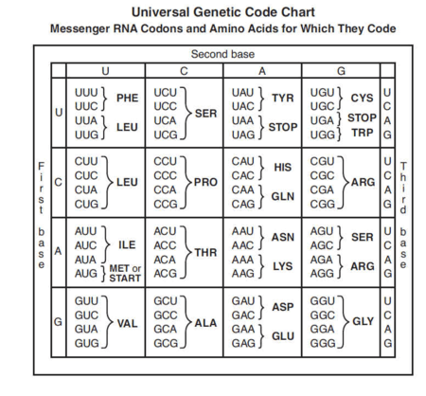](http://www.diffen.com/difference/Image:Universal-Genetic-Code.png)

## References

* [wikipedia:Transcription (genetics)](http://en.wikipedia.org/wiki/Transcription_%28genetics%29" \t "_blank)
* [wikipedia:Translation (biology)](http://en.wikipedia.org/wiki/Translation_%28biology%29" \t "_blank)
* [Internet-Based Tools for Teaching Transcription and Translation - National Human Genome Research Institute](https://www.genome.gov/27552603" \t "_blank)
* [Translation: DNA to mRNA to Protein - Nature](http://www.nature.com/scitable/topicpage/translation-dna-to-mrna-to-protein-393" \t "_blank)

Translation, the second part of the central dogma of molecular biology, describes how the genetic code is used to make amino acid chains. In this lesson, explore the mechanics involved in polypeptide synthesis. Learn the three major steps of translation as you watch tRNA, mRNA, and ribosomes go to work.

## The Three Steps of Translation

Translation is the second step in the central dogma that describes how the genetic code is converted into amino acids. We've talked about how the mRNA codes are recognized by tRNA and how the amino acids are linked together by peptide bonds. A chain of amino acids is also called a polypeptide. Polypeptides are assembled inside the ribosomes, which are tiny organelles on the rough ER of a cell.

Now that we're learning more about the mechanics of translation, we're going to have to start putting the pieces together. We already understand the role of the ribosome and the amino acids in the process of translation, but how does polypeptide assembly actually occur? There are three important steps to the process of translation.

There's a beginning step, called **initiation**, a middle step, called **elongation**, and a final step, called **termination**. These three words may sound familiar to you. The same terms are used in transcription to describe the steps involved in making the mRNA strand. But, here in translation, we're making a polypeptide strand. In either case, we're making a long molecule out of a chain of smaller subunits. So, whether we're referring to transcription or translation, the three terms accurately describe the mechanics of the process. Let's walk through each step, one at a time.

## Initiation

|  |
| --- |
| Description: mRNA Translation Initiation Step |
| In initiation, mRNA is attached to tRNA, which is attached to the specified amino acid. |

We'll start with **initiation**. During initiation, the mRNA, the tRNA, and the first amino acid all come together within the ribosome. The mRNA strand remains continuous, but the true initiation point is the start codon, AUG. Remember that the start codon is the set of three nucleotides that begins the coded sequence of a gene. Remember also that the start codon specifies the amino acid methionine. So, methionine is the name of the amino acid that is brought into the ribosome first.

And, how did methionine get itself to the ribosome? By attaching to the tRNA that contains the right anticodon. The anticodon for AUG is UAC. We know that because of the rules of [complementary base pairing](http://study.com/academy/lesson/complementary-base-pairing-definition-lesson-quiz.html). The tRNA with the anticodon UAC will automatically match to the codon AUG, bringing the methionine along for the ride. So, there you have it - mRNA is attached to tRNA, and tRNA is attached to methionine. That's initiation.

## Elongation

The next step makes up the bulk of translation. It's called **elongation**, and it's the addition of amino acids by the formation of peptide bonds. Elongation is just what it sounds like: a chain of amino acids grows longer and longer as more amino acids are added on. This will eventually create the polypeptide.

Now that we've begun with the start codon, the mRNA shifts a little through the ribosome so that the next codon is up for grabs. Let's say the next codon is UAU. So, now we need a tRNA that has the matching anticodon, AUA. Oh, look! Here's a tRNA with the right anticodon, and it's brought along a tyrosine. Tyrosine is the amino acid that is specified by the codon UAU. The tRNA attaches to the mRNA in the ribosome and lines up tyrosine right next to the waiting methionine. A peptide bond forms between the two amino acids.

Then, the first tRNA leaves everyone else behind and floats off to find more work to do. Poor methionine! Now it's just drifting around like a lonely kite in the wind! That tRNA left methionine hanging by only one anchor: its peptide bond with tyrosine. The tyrosine is still attached to its own tRNA, which, in turn, is clinging to the mRNA inside the ribosome. Already we can see the beginnings of a polypeptide elongating outward.

|  |
| --- |
| Description: mRNA Translation Elongation Step |
| Polypeptides form as amino acids are added during the elongation step. |

Should we walk through that process one more time? Let's keep everything just as we have it here and move on to add our third amino acid. mRNA shifts over again, and now the third codon is ready for a match. What's that codon? CAC. Here comes a tRNA with the matching anticodon, GUG. It's also brought us a histidine, since CAC codes for histidine. The tRNA's anticodon matches up with the mRNA's codon, putting the histidine in perfect position for making a peptide bond with tyrosine.

So, now we have methionine, tyrosine, and histidine all connected. We won't be needing tyrosine's tRNA anymore, so that tRNA detaches and floats away, just like the first one did in the beginning. Now we have an even longer kite; methionine and tyrosine are drifting around with only their peptide bonds to hold them down to the ribosome.

But, the histidine is still connected to its own tRNA, and it'll stay that way until it has the next amino acid to latch onto. You can see how this chain of amino acids would grow longer as each new codon is translated. The addition process and peptide bond formation continues over and over again until the chain is about one hundred amino acids long.